**Francis Torres Rios**

**8/21/2024**

**Introduction**:

* This program tracks the frequency of items purchased at the Corner Grocer. It reads data from an input file, processes it, and offers various options to display the data to the user.

**Design and Functionality**:

* The program is structured around the ItemTracker class, which manages item frequency data using a std::map.
* The class includes methods to load data, display individual item frequencies, print overall frequencies, and display a histogram.
* A data file frequency.dat is automatically generated at the start of the program to back up item frequency data.

**Code Overview**:

* loadItems(): Reads items from CS210_Project_Three_Input_File.txt and populates the itemFrequencies map.
* showFrequency(): Displays the frequency of a specific item entered by the user.
* printOverallFrequency(): Outputs a list of all items and their frequencies.
* printHistogram(): Prints a histogram representation of item frequencies.
* createDataFile(): Writes the frequency data to frequency.dat.
* exitProgram(): Exits the program (with a prompt) and ensures all data is saved.

**Screenshots**:

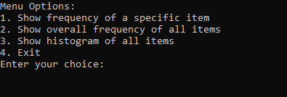

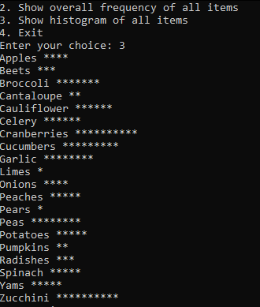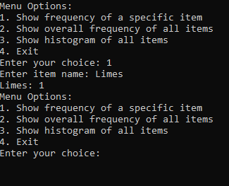

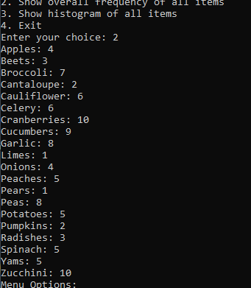

**Conclusion**: The program meets all requirements.